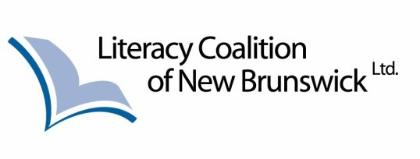

2022 Dr. Marilyn Trenholme Counsell Literacy Awards

Since 1998 the Dr. Marilyn Trenholme Counsell Early Childhood Literacy Awards have been presented to outstanding individuals and/or groups for their work in advancing literacy in New Brunswick. Whether it is developing innovative literacy community-based programs, or championing progressive literacy strategies, these awards showcase the great work being done in this field of literacy, essential skills and lifelong learning. The Dr.
Marilyn Trenholme Counsell Literacy Awards will honour New Brunswickers who have made outstanding contributions in the following categories:

Early Childhood Literacy
- Community Literacy Programs
- Individual Outstanding Contributions to Literacy
- Business/Corporate Literacy Initiatives/Workplace Essential Skills
- Published Author
- Outstanding Effort in Indigenous Literacy

To nominate an individual, organization or business/corporation for the Marilyn Trenholme Counsell Literacy Award, please complete the form below.

Please send nominations via email to: lcnb@nbliteracy.ca

Or by mail to:

Literacy Coalition of New Brunswick 212 Queen St, Suite 303 Fredericton, NB E3B 1A8

For more information contact Lynda Homer, Executive Director, at (506) 457-1227 or by email: lcnb@nbliteracy.ca.

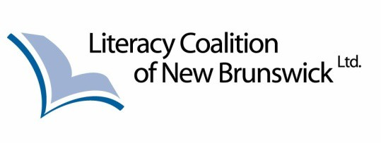

2022 Dr. Marilyn Trenholme Counsell Literacy Awards Nomination Form

Name of Nominee/Organization: _ __ Mailing Address: _ __ Phone: _
E-mail: _

Please describe the contribution your nominee has made to literacy in New Brunswick.

_ _ _
_ _ _
_ _ _
_ _ _
_ _ _

Category, please check one:

- Early Childhood Literacy
- Community Literacy Programs
- Business/Corporate Literacy Initiatives/Workplace Essential Skills
- Individual Outstanding Contribution to Literacy
- Published Author
- Outstanding Effort in Indigenous Literacy

Name of Nominator: _ _ __ Mailing Address: _ __ Phone: _
E-mail: _

A letter of recommendation describing the nominee’s contribution to literacy must accompany the nomination form. Please feel free to include additional letters of reference and photos to support your nomination.

Nomination forms can be sent to: lcnb@nbliteracy.ca

For more information contact Lynda Homer Executive Director at (506) 457-1227

